Assignment 6:

Patient table:

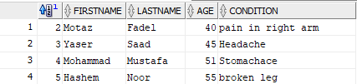

Medicine table:

* Join the patient and Medicine tables to extract the record from both the

table where Patients.PatientID=Medicines.PatientID.

select p.ID, p.FirstName, p.LastName, p.Age, p.Condition, m.MedName

from Patient p

inner join Medicine m

on p.ID = m.PatientID;

Result:

